Week Ending: | DAY: |  |  | Subject: Mathematics
Duration: 60mins per lesson |  |  |  | Strand: Geometry and Measurement
Class: B4 | Class Size: |  |  | Sub Strand: Time
Content Standard:  B4.3.3.3 Demonstrate understanding of time taken by events in minutes and hours |  |  | Indicator:  B4.3.3.3.2-3 Use clock to measure time to complete simple events in minutes and state dates of events and record calendar dates in a variety of formats |  |  | Lesson:  1 OF 1
Performance Indicator:  Learners can use clock to measure time to complete simple events in minutes and state dates of events and record calendar dates in a variety of formats. |  |  |  |  | Core Competencies:  Problem Solving skills; Critical Thinking; Justification of Ideas;
Teaching/ Learning Resources |  | Wall clocks
References: Mathematics Curriculum Pg. 43
DAYS | PHASE 1: STARTER | PHASE 2: MAIN | PHASE 3: REFLECTION
Mon | Review learners understanding in the previous lesson using questions and answers  Engage learners to play games and sing songs to begin the lesson. | Let learners use analogue clocks to tell time by keeping the minutes hand on 12 and moving the hour hand to tell time at the hour mark. | Ask learners to tell you what they have learnt  Give learners individual or home task.
Tues | Let learners solve this  Using only addition, how can you use eight eights to get the number 1000?  Answer: 888+88+8+8+8 | Engage learners to draw/sketch the face of the clock to tell time given.  3:12, 3:25, 3:38, 3:50. | Ask learners to tell you what they have learnt  Give learners individual or home task.
Wed | Engage learners to sing the song  WE CAN COUNT  We class four  We can count  We count 1,2,3,4,5  We count 6,7,8,9,10  We class four can count very well. | Pupils to explore the relationship in the units of time (i.e. 60 seconds = 1 minute; 60 minutes = 1hour)  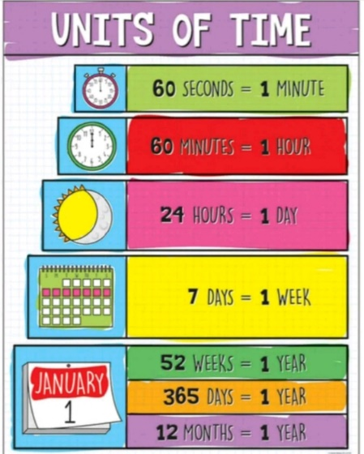  Use digital watches to tell time. Pupils to observe the face of the digital watches and tell the time | Ask learners to tell you what they have learnt  Give learners individual or home task.
Thurs | Let learners solve this  Using only addition, how can you use eight eights to get the number 1000?  Answer: 888+88+8+8+8 | Use the analogue clock to record the time it takes to say walk from the classroom to the canteen/head teacher’s office/library, etc. and back. (mostly minutes)  Use the digital watch to record say the time it takes to walk from the teacher’s table to the cupboard. (mostly seconds)  Ask pupils to tell the time it takes to complete activities like bathing, brushing teeth, ironing a shirt, cooking rice, etc. | Ask learners to tell you what they have learnt  Give learners individual or home task.
Fri | Engage learners to sing the song  WE CAN COUNT  We class four  We can count  We count 1,2,3,4,5  We count 6,7,8,9,10  We class four can count very well. | Record dates in different formats  i. Tuesday, 28th August 2018  ii. 28th August, 2018  iii. 28-Aug-18  iv. 28/08/2018  v. 28.08.18  Ask pupils to write the dates for the following events from a calendar;  i. Independence Day of Ghana  ii. Republic Day  iii. Founders’ Day iv. Farmers’ Day  v. Workers’ Day | Ask learners to tell you what they have learnt  Give learners individual or home task.  Next lesson: read and interpret graphs

